Tutorio for DBE

WEEK 3

Q1: Online marketing map for **skyscanner**

**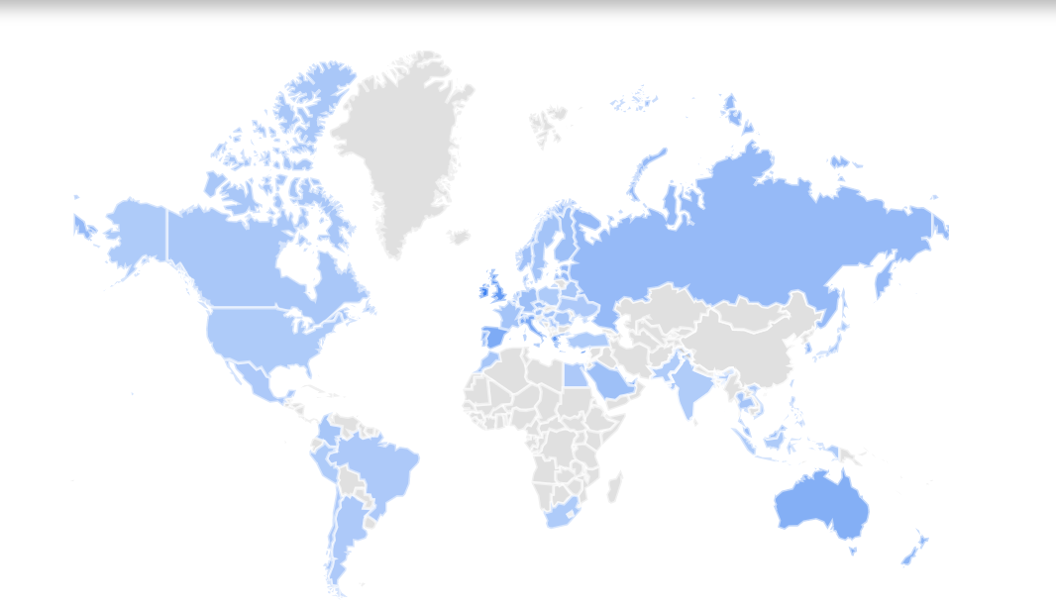**

**Top 5 countries:**

1. **The republic of Cyprus**
2. **Republic of Ireland**
3. **Republic of Malta**
4. **The United Kingdom**
5. **The republic of Greece**

**(1)Main customer segment(s) being targeted**

Answer: The people who come from EU, who will have the short trip, who want to save money, who are not care about the air company.

1. **Persona**

A person from Scotland, and he wants to have a three-days travel to Iceland, it is the short trip, and he is not care about the air company, but he wants to find the cheapest ticket on website.

1. **Price. [Travel fare aggregator website](https://en.wikipedia.org/wiki/Travel_website" \l "Fare_aggregators_and_metasearch_engines" \o "), [Metasearch engine](https://en.wikipedia.org/wiki/Metasearch_engine" \o "Metasearch engine)**
2. **relevant partner sites for the business**

Different kinds of air companies, hotels, car rent companies, insurance companies.

1. Other Metasearch engine websites (like wiki, momondo, lastminute...)

Q2:

1. Monday.com
2. MapBusinessOnline.com <https://www.mapbusinessonline.com/Solution.aspx/MarketAnalysis>
3. Funnel.io